**SRM INSTITUTE OF SCIENCE AND TECHNOLOGY**

**DEPARTMENT OF COMPUTER SCIENCE AND ENGINEERING**

**KATTANKULATHUR – 603 203**

**15IT304J- Web Programming Register**

**Number: RA1711003011471**

**Name: Manvi Singh Chandel**

**Experiment No : 1**

**Date : 13/08/2020**

**Aim: To Create a Static Home Page(resume) by using basic HTML tags.**

**Input:**

<!DOCTYPE html>

<html lang="en">

<head>

<meta charset="UTF-8">

<meta name="viewport" content="width=device-width, initial-scale=1.0">

<title>Resume</title>

<link rel="stylesheet" href="style.css">

</head>

<body>

<table cellspacing="20">

<tr>

<td><img src="circle-cropped.png" alt="Manvi's profile picture"></td>

<td><h1>Manvi Chandel</h1>

<p><em>Web Developer and student at <strong><a href="https://www.srmist.edu.in/">SRM University</a></strong></em></p>

<p>I am a 4th year student and learning Web Programming..</p></td>

</tr>

</table>

<hr size="3" noshade>

<h3>Education</h3>

<table cellspacing="15">

<tr>

<td>Class X </td>

<td> St. Joseph's Convent(CBSE)</td>

<td>CGPA-9.4</td>

</tr>

<tr>

<td>Class XII </td>

<td> St. Joseph's Convent(CBSE)</td>

<td>77%</td>

</tr>

<tr>

<td>Undergraduate Education </td>

<td> SRM Institute of Science and Technology</td>

<td>79.5%</td>

</tr>

</table>

<hr>

<h3>Skills</h3>

<table cellspacing="10">

<tr>

<th>Java</th>

</tr>

<tr>

<th>MySql</th>

</tr>

<tr>

<th>HTML 5</th>

</tr>

<tr>

<th>C++</th>

</tr>

</table>

<hr>

<h3>Work and Experiences</h3>

<table cellspacing="15">

<tr>

<th>Dates</th>

<th>Work</th>

</tr>

<tr>

<td>May 2019</td>

<td>Cybersecurity with Ethical Hacking at Techobyte Technologies</td>

</tr>

<tr>

<td>May 2020</td>

<td>HTML5, CSS and C Programming course Certificate </td>

</tr>

</table>

<hr>

<h3>My Hobbies/Interests</h3>

<ol>

<li>Dancing</li>

<li>Basketball</li>

<li>Movies</li>

<li>Music</li>

</ol>

<a href="contact.html">Contact me</a>

</body>

</html>

**OUTPUT:-**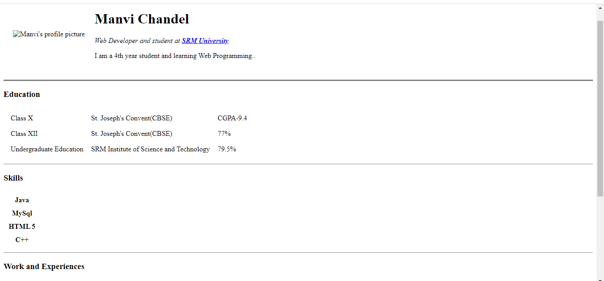

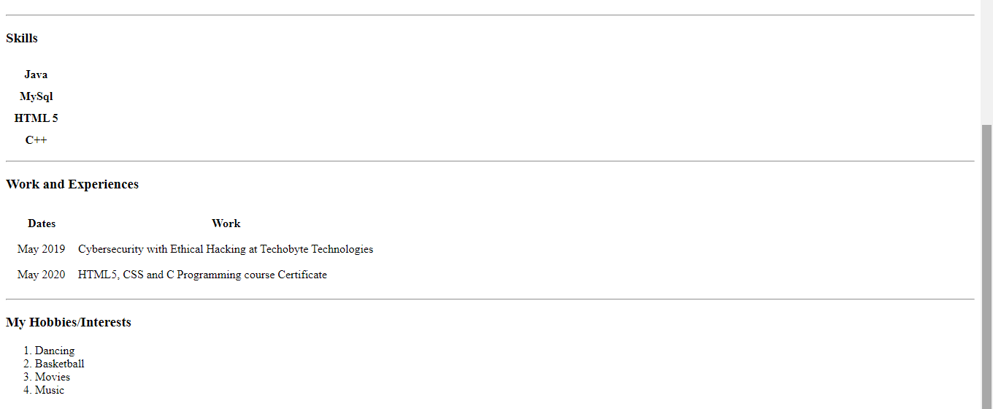

**Result: A homepage using HTML tags was created.**